Supplemental materials for: Podlesnik, C. A., Martinez-Perez, C. N., Montague, K. L., Ritchey, C. M., Lamperski, M. S., & Kuroda, T. Evaluating multiple-context training to mitigate renewal following differential reinforcement. Journal of the Experimental Analysis of Behavior.

Table S1

Experiment 1 Participant Demographics (N=151)
Measure | M (SD) | n | Percent of Sample
Age | 38.34 (11.15)
Gender
Man |  | 68 | 44.74
Woman |  | 83 | 54.61
Genderqueer, nonbinary, genderfluid |  | 1 | 0.66
Race/Ethnicity
White |  | 106 | 69.74
Black/African American |  | 19 | 12.50
Asian |  | 15 | 9.87
Hispanic/Latino (of any race) |  | 9 | 5.92
Native American/Alaska Native |  | 1 | 0.66
Native Hawaiian/Pacific Islander |  | 1 | 0.66
Other |  | 1 | 0.66
Color Blindness |  | 1 | 0.66
Red-green |  | 1 | 0.66
Note. M=Mean; SD=Standard deviation. We did not exclude participants with color blindness due to redundant cues arranged between responses and during reinforcer deliveries.

Table S2

Experiment 2 Participant Demographics (N=153)
Measure | M (SD) | n | Percent of Sample
Age | 38.62 (11.18)
Gender
Man |  | 55 | 37.16
Woman |  | 86 | 58.11
Genderqueer, nonbinary, genderfluid |  | 6 | 4.05
Prefer not to answer |  | 1 | 0.68
Race/Ethnicity
White |  | 95 | 64.19
Black/African American |  | 25 | 16.89
Asian |  | 16 | 10.81
Hispanic/Latino (of any race) |  | 7 | 4.73
Indigenous |  | 1 | 0.68
Native American/Alaska Native |  | 1 | 0.68
Other |  | 3 | 2.03
Color Blindness |  | 1 | 0.68
Red-green |  | 1 | 0.68
Note. M=Mean; SD=Standard deviation. We did not exclude participants with color blindness due to redundant cues arranged between responses and during reinforcer deliveries.

Table S3

Exclusions by Group and Criterion for all experiments.
 | Criteria (n)
 | 1 | 2 | 3 | 4
Experiment 1
ABCDA | 0 | 0 | 17 | 0
ABBBA | 0 | 0 | 13 | 1
ABBB | 0 | 0 | 13 | 1
Total | 0 | 0 | 43 | 2
Experiment 2
ABCDE | 0 | 0 | 17 | 0
ABBBE | 0 | 0 | 10 | 1
ABBBB | 0 | 0 | 15 | 0
Total | 0 | 0 | 42 | 1
Note. Criterion 1 = > 5 responses per second; Criterion 2 = no responses in the last 2 min in Phase 1 or Phase 2; Criterion 3 = target responding did not decrease below 50% of Phase-1 levels; Criterion 4 = Did not complete experiment, survey, or did not engage with consummatory response.

Table S4
Context Counterbalancing Across Experiments
 |  |  |  | Context
 | Group | Squad | Target Loc. | Phase 1 | Phase 2 | Phase 3
Experiment 1 | ABA | 1 | Left | Beach | Desert | Beach
 |  | 2 | Right | Beach | Desert | Beach
 |  | 3 | Left | Desert | Beach | Desert
 |  | 4 | Right | Desert | Beach | Desert
 | ABCDA | 5 | Left | Beach | DSMSMDMDS | Beach
 |  | 6 | Right | Beach | DSMSMDMDS | Beach
 |  | 7 | Left | Beach | MDSDSMSMD | Beach
 |  | 8 | Right | Beach | MDSDSMSMD | Beach
 |  | 9 | Left | Desert | BSMSMBMBS | Desert
 |  | 10 | Right | Desert | BSMSMBMBS | Desert
 |  | 11 | Left | Desert | MBSBSMSMB | Desert
 |  | 12 | Right | Desert | MBSBSMSMB | Desert
 | ABB | 13 | Left | Beach | Desert | Desert
 |  | 14 | Right | Beach | Desert | Desert
 |  | 15 | Left | Desert | Beach | Beach
 |  | 16 | Right | Desert | Beach | Beach
Experiment 2 | ABE | 1 | Left | Beach | Desert | Field
 |  | 2 | Right | Beach | Desert | Field
 |  | 3 | Left | Desert | Beach | Field
 |  | 4 | Right | Desert | Beach | Field
 | ABCDE | 5 | Left | Beach | DSMSMDMDS | Field
 |  | 6 | Right | Beach | DSMSMDMDS | Field
 |  | 7 | Left | Beach | MDSDSMSMD | Field
 |  | 8 | Right | Beach | MDSDSMSMD | Field
 |  | 9 | Left | Desert | BSMSMBMBS | Field
 |  | 10 | Right | Desert | BSMSMBMBS | Field
 |  | 11 | Left | Desert | MBSBSMSMB | Field
 |  | 12 | Right | Desert | MBSBSMSMB | Field
 | ABB | 13 | Left | Beach | Desert | Desert
 |  | 14 | Right | Beach | Desert | Desert
 |  | 15 | Left | Desert | Beach | Beach
 |  | 16 | Right | Desert | Beach | Beach
Note. Target Loc. = target button location (left vs. right); B = Beach, D = Desert, M = Mountain, S = Snow.

Table S5
Cohen’s d from Model and Raw Values
 | Raw Values |  | Model Values
Comparison | Cohen's d | 95% CI | Cohen's d | 95% CI
Experiment 1
Target
Last bin Phase 1
ABBBA vs. ABBBB | 0.13 | -0.26, 0.52 | 0.06 | -0.16, 0.29
ABCDA vs. ABBBB | 0.12 | -0.27, 0.51 | 0.05 | -0.17, 0.28
ABBBA vs. ABCDA | -0.01 | -0.40, 0.38 | 0.01 | -0.23, 0.21
Last bin Phase 2
ABBBA vs. ABBBB | -0.20 | -0.60, 0.18 | 0.04 | -0.71, 0.61
ABCDA vs. ABBBB | 0.37 | -0.03, 0.76 | 1.16 | 0.50, 1.82
ABBBA vs. ABCDA | 0.60 | 0.21, 1.00 | 1.11 | 0.46, 1.76
First bin Phase 3
ABBBA vs. ABBBB | 0.86 | 0.46, 1.28 | 0.89 | 0.33, 1.45
ABCDA vs. ABBBB | 0.67 | 0.26, 1.07 | 1.05 | 0.49, 1.61
ABBBA vs. ABCDA | 0.27 | -0.12, 0.66 | -0.17 | -0.71, 0.38
Last bin Phase 1 vs. Last bin Phase 2
ABBBA | 2.70 | 2.10, 3.30 | 3.48 | 2.98, 3.95
ABCDA | 1.95 | 1.46, 2.44 | 2.36 | 1.89, 2.83
ABBBB | 2.09 | 1.58, 2.60 | 3.47 | 2.99, 3.95
Last bin Phase 2 vs. First bin Phase 3
ABBBA | 1.88 | 1.13, 2.62 | 1.41 | 1.01, 1.82
ABCDA | 0.36 | -0.06, 0.78 | 0.45 | 0.06, 0.84
ABBBB | 0.04 | -0.35, 0.42 | 0.57 | 0.15, 0.99
Alternative
Last bin Phase 1
ABBBA vs. ABBBB | 0.22 | -0.17, 0.61 | 0.12 | -0.31, 0.55
ABCDA vs. ABBBB | 0.21 | -0.18, 0.60 | 0.27 | -0.17, 0.71
ABBBA vs. ABCDA | -0.01 | -0.40, 0.38 | 0.15 | -0.28, 0.59
Last bin Phase 2
ABBBA vs. ABBBB | 0.02 | -0.37, 0.41 | 0.06 | -0.16, 0.31
ABCDA vs. ABBBB | 0.01 | -0.39, 0.40 | -0.10 | -0.36, 0.15
ABBBA vs. ABCDA | 0.02 | -0.37, 0.41 | 0.17 | -0.09, 0.42
First bin Phase 3
ABBBA vs. ABBBB | -0.45 | -0.84, -0.05 | -0.18 | -0.42, 0.07
ABCDA vs. ABBBB | -0.21 | -0.60, 0.19 | -0.13 | -0.37, 0.11
ABBBA vs. ABCDA | -0.23 | -0.62, 0.16 | -0.05 | -0.29, 0.20
Last bin Phase 1 vs. Last bin Phase 2
ABBBA | 7.76 | 5.71, 9.81 | 3.29 | 2.81, 3.41
ABCDA | 7.81 | 5.93, 9.80 | 3.27 | 2.99, 3.59
ABBBB | 5.97 | 4.35, 7.59 | 3.11 | 2.97, 3.58
Last bin Phase 2 vs. First bin Phase 3
ABBBA | 0.39 | 0.03, 0.76 | 0.24 | 0.11, 0.37
ABCDA | 0.19 | -0.19, 0.58 | 0.03 | -0.10, 0.16
ABBBB | -0.01 | -0.43, 0.40 | < 0.01 | -0.13, 0.13
Experiment 2
Target
Last bin Phase 1
ABBBE vs. ABBBB | 0.02 | -0.37, 0.41 | 0.05 | -0.19, 0.29
ABCDE vs. ABBBB | 0.37 | -0.02, 0.76 | 0.12 | -0.12, 0.36
ABCDE vs. ABBBE | 0.37 | -0.02, 0.76 | 0.17 | -0.07, 0.40
Last bin Phase 2
ABBBE vs. ABBBB | 0.17 | -0.21, 0.56 | 0.42 | 0.03, 1.14
ABCDE vs. ABBBB | 0.41 | 0.02, 0.80 | 0.71 | 0.01, 1.42
ABCDE vs. ABBBE | 0.19 | -0.20, 0.58 | 1.13 | 0.41, 1.85
First bin Phase 3
ABBBE vs. ABBBB | 0.91 | -0.50, 1.32 | 0.86 | 0.35, 1.38
ABCDE vs. ABBBB | 0.62 | 0.23, 1.02 | 0.64 | 0.12, 1.16
ABCDE vs. ABBBE | 0.38 | -0.02, 0.77 | -0.22 | -0.73, 0.28
Last bin Phase 1 vs. Last bin Phase 2
ABBBE | 1.79 | 1.33, 2.25 | 4.68 | 3.37, 6.00
ABCDE | 2.22 | 1.69, 2.74 | 2.06 | 0.78, 3.34
ABBBB | 1.65 | 1.23, 2.08 | 1.79 | 0.47, 3.11
Last bin Phase 2 vs. First bin Phase 3
ABBBE | 1.09 | 0.56, 1.61 | 1.82 | 1.27, 2.37
ABCDE | 0.46 | 0.03, 0.88 | 0.46 | -0.07, 0.99
ABBBB | 0.23 | -0.23, 0.68 | 0.54 | 0.01, 1.07
Alternative
Last bin Phase 1
ABBBE vs. ABBBB | -0.08 | -0.47, 0.31 | -0.27 | -0.75, 0.21
ABCDE vs. ABBBB | -0.07 | -0.46, 0.31 | -0.01 | -0.49, 0.47
ABCDE vs. ABBBE | 0.002 | -0.39, 0.39 | 0.26 | -0.74, 0.22
Last bin Phase 2
ABBBE vs. ABBBB | 0.02 | -0.37, 0.41 | 0.18 | -0.14, 0.51
ABCDE vs. ABBBB | 0.06 | -0.33, 0.45 | 0.14 | -0.18, 0.47
ABBBE vs. ABCDE | 0.04 | -0.34, 0.43 | 0.04 | -0.29, 0.36
First bin Phase 3
ABBBE vs. ABBBB | -0.41 | -0.80, 0.02 | -0.04 | -0.36, 0.38
ABCDE vs. ABBBB | 0.08 | 0.46, -0.31 | 0.17 | -0.15, 0.49
ABCDE vs. ABBBE | 0.54 | 0.15, 0.94 | 0.22 | -0.11, 0.54
Last bin Phase 1 vs. Last bin Phase 2
ABBBE | 4.19 | 3.05, 5.33 | 3.51 | 3.15, 3.86
ABCDE | 3.77 | 2.76, 4.78 | 3.21 | 2.86, 3.56
ABBBB | 2.72 | 1.87, 3.57 | 3.05 | 2.70, 3.40
Last bin Phase 2 vs. First bin Phase 3
ABBBE | 0.44 | 0.08, 0.81 | 0.27 | 0.11, 0.42
ABCDE | 0.07 | -0.31, 0.45 | 0.01 | -0.14, 0.17
ABBBB | 0.07 | -0.30, 0.44 | 0.04 | -0.12, 0.20
Note. CI = Confidence intervals. Effect sizes for between-groups raw data values were calculated using a web-based effect-size calculator (Wilson, 2023). Effect sizes for within-group/between-phases raw data values were calculated using a web-based within-case effect size calculator (Pustejovsky et al., 2024) to account for autocorrelation of cases.

Pustejovsky, J. E, Chen, M., Grekov, P., & Swan, D. M. (2024). Single-case effect size calculator (Version 0.7.3) [Web application]. https://jepusto.shinyapps.io/SCD-effect-sizes/

Wilson, D. B. (2023). Practical meta-analysis effect size calculator (Version 2023.11.27).

Justification for Use of GLMM
Generalized linear mixed models (GLMM) offer distinct advantages over traditional statistical techniques (e.g., ANOVAs, t-tests, linear regression) when analyzing data involving repeated measures or hierarchical structures. First, GLMMs include fixed-effect parameters which estimate differences among conditions (e.g., phase, group, time) and its interactions. Second, GLMMs do not assume independence across observations by including random effects, which quantify the individual variation when more than one response is measured per individual, as is the case in the present study. Failure to account for random effects when it is necessary could result in pseudoreplication and would warrant careful interpretation of the results from both the researchers and the readers (Bolker et al., 2009). Third, GLMMs are capable of handling nonnormal data as a result of data with many zero values or missing (unbalanced) data. Trying to use traditional methods, including nonparametric tests, with nonnormal data would often require data transformation (e.g., log, square root, box cox), – which is not possible with zero values – or violating statistical assumptions. Thus, the use of GLMMs enhances statistical power, accommodates missing and nonnormal data more effectively, and allows researchers to model complex dependency structures inherent in behavioral data, making it a robust and flexible choice for analyzing data from the current study.
Bolker, B. B., Brooks, M. E., Clark. C. J., Geange, S. W., Poulsen, J. R., Stevens, H. H., & White, J. S. (2009). Generalized linear models: a practical guide for ecology and evolution. Trends in Ecology and Evolution, 24 (3), 127-135. https://doi.org/10.1016/j.tree.2008.10.008

Analysis of Responses Across Phases 2 and 3
To assess potential group differences in overall reductions in target responding across Phases 2 and 3, we conducted a “savings” analysis comparing the total number of target responses per minute during Phases 2 and 3 combined across groups (see Figure 5 of main document). Specifically, we calculated the mean total target responses in each group and compared experimental groups against the control group. In Experiment 1, we compared Groups ABBBA and ABCDA to Group ABBBB. Groups ABBBA (M = 116.86, SD = 69.45) and ABBBB (M = 108.70, SD = 87.82) had comparable mean total target responses in Phases 2 and 3 combined (t = 0.52, p = .6060, d = 0.10). Group ABCDA (M = 142.80, SD = 65.16) engaged in significantly greater mean total target responding during Phases 2 and 3 combined than Group ABBBB (t = 2.21, p = .0300, d = 0.44), indicating more persistent target responding in the MCT group during Phases 2 and 3. In Experiment 2, we compared Groups ABBBE and ABCDE to Group ABBBB. There was not a statistically significant difference between Groups ABBBE (M = 116.53, SD = 81.77) and ABBBB (M = 100.61, SD = 58.87) based on p-values (t = 1.13, p = .2621). However, we did capture a small-effect size difference between Groups ABCDE and ABBBB (d = 0.22), indicating target responding might be more persistent in the group transitioning to a novel context in Phase 3 compared to Group ABBBB. Group ABCDE (M = 146.55, SD = 83.22) engaged in significantly greater mean total target responding during Phases 2 and 3 combined than Group ABBBB (t = 3.22, p = .0018, d = 0.64), indicating more persistent target responding in the MCT group during Phases 2 and 3.

Page Instructions
Play an easy button-pressing game for academic research. You will earn base pay = $4.00. Bonus pay from in-game points could earn you even more for more optimal performances. A simple survey follows about your participation. Click the link below to begin. To access the study, use the password: XXXXXX.

Task Instructions
Page 1: Hello and thank you for choosing this task! IMPORTANT: Please read the following
instructions before beginning!
1. Payment for participating requires you stay on this tab of your web browser for the entire duration of the task. Please close any other tabs that you have open that could distract you. We use server-side coding so we will know if and how long you leave the task page. You WILL NOT BE PAID for participation if you violate this rule – no exceptions.
2. Do not press the back page button or refresh button at any time during the task. Doing so will end the task and your opportunity for payment.
3. Only do this task on a laptop or desktop computer – do NOT USE a phone or tablet.
4. Use one of the following web browsers: Google Chrome, Mozilla Firefox, or Microsoft Edge. 5. When the task is over, a unique payment code will be displayed. Enter this code for payment. Press this button when ready to continue:
Page 2: After pressing the PROCEED button below, you will play a game to earn as many points as you can. A new page will appear and you will see one or more buttons. Pressing buttons could sometimes increase or decrease your points. Points will be tracked by a bar on the screen.
The game will take approximately 15-20 minutes to complete. If you complete the game, you will be paid for completing the task and every point earned will be worth US$0.00012.
Failing to begin engaging with the game within 30 seconds after proceeding will terminate the opportunity to participate in this task and the opportunity for payment. Therefore, do not proceed unless you are ready to begin and complete the game.
Press the PROCEED button when ready to continue and please begin the game as soon as the interface appears.
Survey Questions
1) On a scale of 1 (definitely no) to 100 (definitely yes), how sure are you there was a button
with a RED HEART at some point during the GAME?
2) On a scale of 1 (definitely no) to 100 (definitely yes), how sure are you there was a button with a BLACK SPADE at some point during the GAME?
3) On a scale of 1 (definitely no) to 100 (definitely yes), how sure are you there was a button with a RED DIAMOND at some point during the GAME?
4) On a scale of 1 (definitely no) to 100 (definitely yes), how sure are you there was a button with a BLACK CLUB at some point during the GAME?
5) On a scale of 1 (not effective) to 100 (very effective), how sure are you the button with a RED HEART was effective for earning points at some point during the GAME?
6) On a scale of 1 (not effective) to 100 (very effective), how sure are you the button with a BLACK SPADE was effective for earning points at some point during the GAME?
7) On a scale of 1 (not effective) to 100 (very effective), how sure are you the button with a RED DIAMOND was effective for earning points at some point during the GAME?
8) On a scale of 1 (not effective) to 100 (very effective), how sure are you the button with a BLACK CLUB was effective for earning points at some point during the GAME?
9) On a scale of 1 (definitely no) to 100 (definitely yes), how sure are you there was a BEACH in the background during the game?;
10) On a scale of 1 (definitely no) to 100 (definitely yes), how sure are you there was a SNOW SCENE in the background during the game?;
11) On a scale of 1 (definitely no) to 100 (definitely yes), how sure are you there was a FOREST in the background during the game;
12) On a scale of 1 (definitely no) to 100 (definitely yes), how sure are you there was a LAKE in the background during the game;
13) On a scale of 1 (definitely no) to 100 (definitely yes), how sure are you there was a MOUNTAIN in the background during the game?;
14) On a scale of 1 (definitely no) to 100 (definitely yes), how sure are you there was a DESERT in the background during the game?;
15) What do you think was the overall purpose of the study you just completed? If you do not know, please feel free to respond, I don’t know. Leave the question blank if you prefer not to answer.;
16) Did you have a certain way you tried to get points through the game?;
- Yes
- No
- I prefer not to answer
17) Please describe your overall strategy that you used throughout the study. If you did not have a strategy, please feel free to respond, I did not have a strategy. Leave the question blank if you prefer not to answer.;
18) Did you change the way you tried to get points during the game;
- There was not a certain way I tried to get points throughout the game
- I prefer not to answer
- I did not change the way I tried to get points during the game
- I did change the way I tried to get points
19) If there is any other information you wish to explain about your experience during the study, please describe here:;
20) How old are you?;
21) What is your gender?;
- Genderqueer, Non-binary, Genderfluid
- Prefer not to say
- Man
- Woman
22) What is your nationality?;
23) What is your race/ethnicity?;
- Asian
- Black or African American
- Hispanic or Latino (of any race)
- Indigenous
- Native American or Alaskan Native
- Native Hawaiian or Pacific Islander
- White
24) On a scale of 1 (definitely no) to 100 (definitely yes), how stressed were you during the game?;
25) Do you have any problems with seeing color?;
- No
- Unknown
- Yes, red-green color blindness
- Yes, blue-yellow color blindness
- Yes, total color blindness
- Yes, other
26) What device did you use to press buttons during the task? Please select one of the following options:
- External Computer Mouse
- Trackpad
- Computer Touchscreen
- Other
27) Please include your Prolific ID to receive your bonus payment for completing the task.

Interlude Appearance

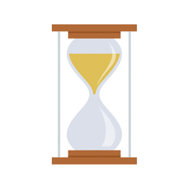

Note. gif of rotating hourglass image shown during the interludes.

Figure S1.
QQ plots of residuals for Experiment 1

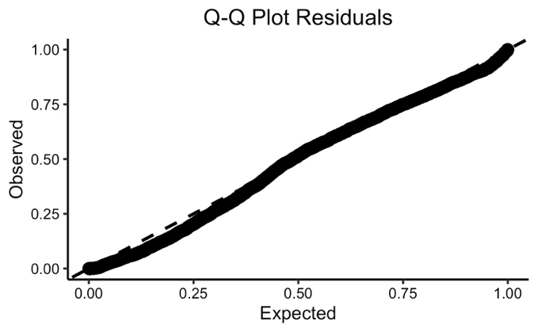
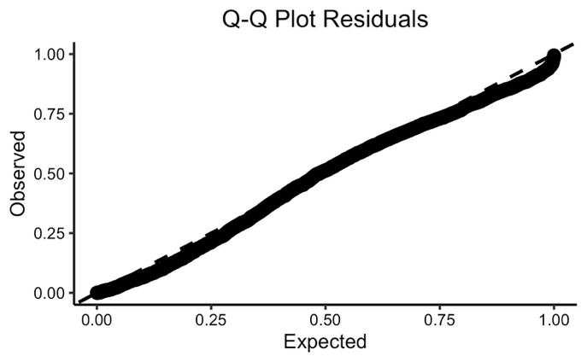

Note. Target in the top panel and alternative in the bottom panel

Figure S2.
QQ plots of residuals for Experiment 2

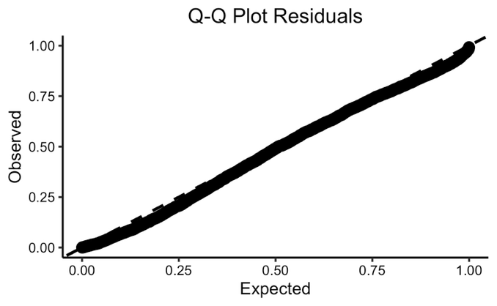
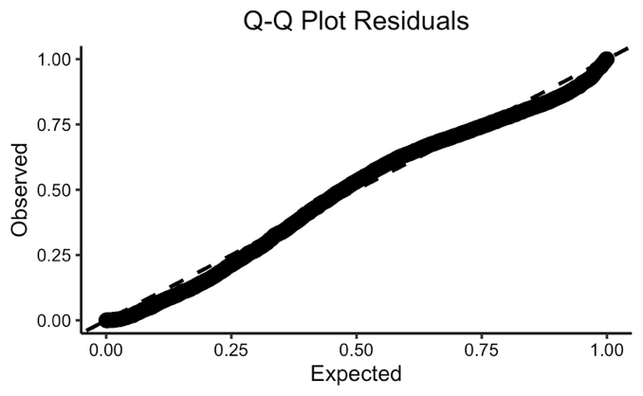
Note. Target in the top panel and alternative in the bottom panel

